user manual

Bariatric Comfort Foam Mattress

Bariatric Comfort Foam Mattress is a pressure relieving foam mattress designed for bariatric patients.

For patients in need of pressure relief and a wide mattress. Used in hospitals, institutions, and home care.

Maximum user weight 325 kg.

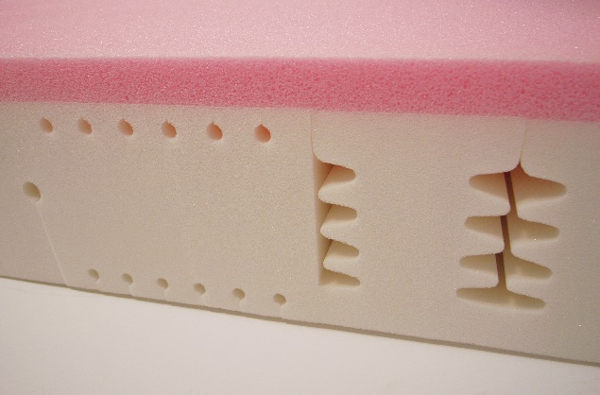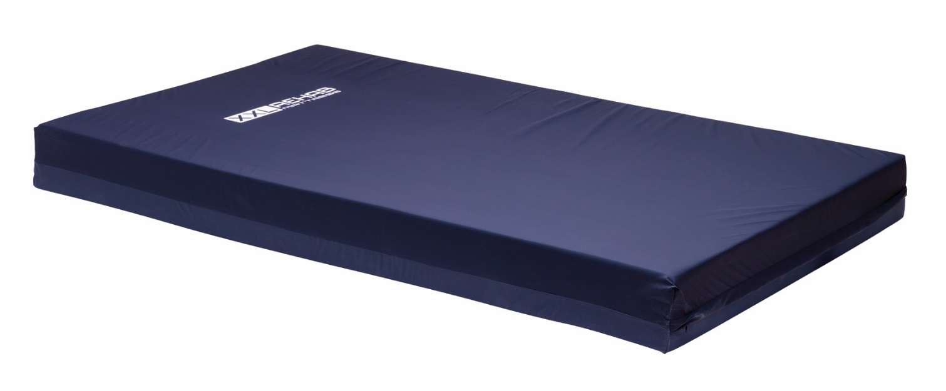



Medical device

Cobi Rehab and Cobi Rehab’s suppliers comply with UN conventions on child and forced labor and ILO 029, C132 and C182.

.

Table of content

1. Safety 3

2. Symbols 4

3. Specifications 5

4. Use 6

5. Bariatric Comfort Foam Mattress 7

6. Warranty 8

7. Accessories 8

|  |  |
| --- | --- |
|  | WARNING |
| Do not use Bariatric Comfort Foam Mattress without instruction from trained staff or from persons who have received instruction in the use of the mattress.  Improper operation may injure the user. Using Bariatric Comfort Foam Mattress for people weighing more than the maximum user weight of 325 kg increases the risk of damaging the mattress.  Read this user manual carefully before using the Bariatric Comfort Foam Mattress.  Pay particular attention to Safety Instructions .  Cobi Rehab assumes no responsibility for any damage to the product nor for personal injury caused by incorrect installation or incorrect use of the Bariatric Comfort Foam Mattress.  Immediately contact Cobi Rehab if parts are damaged or missing.  Never use your own spare parts.  Cobi Rehab cannot be held responsible for errors or accidents occurring after repairs made without the written permission of Cobi Rehab | |

|  |  |
| --- | --- |
|  | SAFETY INSTRUCTIONS |
| Only cover Bariatric Comfort Foam Mattress with one layer. It allows water vapor to penetrate the layer.  Use only breathable incontinence cover on the foam mattress.  Bariatric Comfort Foam Mattress should be thoroughly disinfected if given to a new user. This is done to avoid cross-contamination.  Bariatric Comfort Foam mattress must match the height of a possible bed rail. The bed rail must be higher than the foam mattress, otherwise the user can fall off the bed.  External sources of heat and cold (e.g., sunlight or other environmental factors) may influence the surface of the Bariatric Comfort  Foam Mattress temperature.  Contact Cobi Rehab for all types of service and repair. | |

## 1. Safety

|  |  |
| --- | --- |
|  | Caution! |
|  | Declaration of conformity, Medical Device Regulation, EU 2017/745 |
|  | Cobi Catalogue number |
|  | Serial number |
|  | Year of manufacture |
|  | Manufacturer |
|  | Medical device |
|  | Maximum user weight |
|  | Consult the manual |
| See an example of an CE-label below. | |

## 2. Symbols

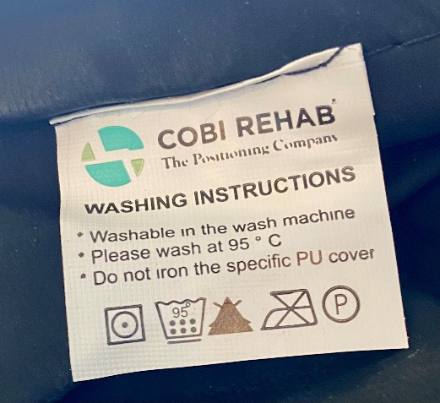

This user guide contains important information about the use of Bariatric Comfort Foam Mattress and the target group of the mattress.

It also includes a wide range of specifications on the Bariatric Comfort Foam Mattress.

The most recent version of this user guide can be found on our website. Check if the version you are reading now is the most recent.

If you need a user guide that is written in a larger font size, the product sheet is available in PDF format at cobirehab.com, which can be scaled up to the required font size.

You can always contact Cobi Rehab on telephone +45 7025 2522 or e-mail cobi@cobi.dk if you want more information about Bariatric Comfort Foam Mattress.

Cobi Rehab reserves the right to change the product specifications without providing prior notice.

Product safety notices and product recalls can be viewed on the website.

|  |  |  |
| --- | --- | --- |
| Specifications | |  |
| Maximum user weight | | 325 kg |
| Usable up to pressure ulcers | | Stage 1 |
| ISO classification | | 18 12 18 - 25 |
| Expected product life | | 7 years |
| Risk class | | I |
| User manuals and product sheets are available on the website and can be scaled up to large font size for the visually impaired. | | |
| Environmentally sound disposal | Return the mattress for recycling | |
| The surface temperature can rise when the wheelchair is exposed to external heat sources e.g., sunlight. | | |

|  |  |  |  |
| --- | --- | --- | --- |
| Mattress | | |  |
| Length | | | 200/220 cm |
| Width | | | 100/120/140 cm |
| Height | | | 18 cm |
| Weight | | | 12/13/14 kg |
| Can be applied directly to the bed base | | | Yes |
| Usable for adjustable bed base | | | Yes |
| Mattress base material | Heavy Duty PU foam | | |
| Mattress top material | | Visco elastic PUR foam | |
| Flame retardant mattress | | Yes | |

|  |  |  |  |  |
| --- | --- | --- | --- | --- |
| Cover | | |  | |
| Removable, allergy-friendly, washable and disinfectable incontinence cover | | | | Yes |
| Cover material | | 100% polyurethane | | |
| Flame retardant cover | Yes | | | |
| The cover complies with the ROHS directive | Yes | | | |

## 3. Specifications

Bariatric Comfort Foam Mattress is used in institutions, home care and in private homes.

Bariatric Comfort Foam Mattress has a pressure relieving effect.

Bariatric Comfort Foam Mattress is specifically designed to prevent and treat pressure ulcers in low-risk category 1.

Bariatric Comfort Foam Mattress is for users with a user weight of maximum 325 Kg.

Bariatric Comfort Foam Mattress can contribute to better comfort and sleep as well as reduction of pressure in the contact area.

Bariatric Comfort Foam Mattress is easy to clean and to reuse.

Contraindications

Always consult a doctor or therapist before assigning a Bariatric Comfort Foam mattress to a patient.

## 4. Use

Bariatric Comfort Foam Mattress is made of two different layers of quality foam. The base layer is a thick base layer of Heavy Duty PU foam cut into springs.

The top layer consists of three cm viscoelastic foam, which provides comfort and pressure relief.

Bariatric Comfort Foam Mattress is available in size:

100 X 200 cm  
120 X 200 cm  
100 X 220 cm  
120 X 220 cm  
140 X 220 cm

### 4.2 Foam Mattress

### 4.2 Skummadras

### 4.2 Foam Mattress

### 4.2 Skummadras

The cover is removable, breathable, stretchable, and anti-bacterially treated on the surface.

The cover is protected against liquid penetration and is flame retardant.

The cover can be washed at 95°C and tumble dried on low heat or hang to dry if possible.

The cover must not be ironed.

The cover has a zipper on three sides. The zipper is covered of an overlap of the cover.

### 4.3 Cover

### 4.3 Betræk

### 4.3 Cover

### 4.3 Betræk

Before use

Place Bariatric Comfort Foam Mattress on the bed. Make sure that the cover is fastened correctly the foam mattress. Lay one loose sheet over the foam mattress. Bariatric Comfort Foam mattress can be turned, which can extend the life of the foam mattress.

Hand-check

Nursing staff and/or therapist should regularly check the foam mattress during use. Place the hand under the user's heaviest part (e.g., the pelvis). User may only be halfway down in the mattress.

Storage (including long-term storage)

Place the mattress lying flat and without anything lying on top, in temperatures between 10 to 40°C.

Maintenance

Check regularly Bariatric Comfort Foam Mattress for damage to ensure optimal effect. If the cover is damaged, it must be replaced immediately.

Cover cleaning

The cover can be machine washed at a maximum of 95°C. Do not use bleach. Cover can withstand dryer but must not be ironed.

Disinfection of cover

Bariatric Comfort Foam Mattress can be disinfected with ethanol 70- 85% or a chlorine product 1000-1200 ppm. The cover should be thoroughly disinfected if the mattress is given to a new user. This is done to avoid cross-contamination and infections.

Local cleaning and disinfection procedures must always be followed.

In case of cardiac arrest

First aid and CPR can be given directly on the foam mattress.

Disposal

Products that are no longer in use must disposed of in an environmentally sound manner. Contact the local authorities for guidance on correct disposal.

### 5.1 Before, under, and after use

## 5. Bariatric Comfort Foam Mattress

## 6. Warranty

|  |  |  |  |
| --- | --- | --- | --- |
| Accessories | Length | Width | Item no |
| Cover Bariatric Comfort Foam Mattress | 200 cm | 100 cm | 0240-999-009 |
| Cover Bariatric Comfort Foam Mattress | 200 cm | 120 cm | 0240-999-011 |
| Cover Bariatric Comfort Foam Mattress | 220 cm | 100 cm | 0240-999-010 |
| Cover Bariatric Comfort Foam Mattress | 220 cm | 120 cm | 0240-999-012 |
| Cover Bariatric Comfort Foam Mattress | 220 cm | 140 cm | 0240-999-015 |

Cobi Rehab warrants that Bariatric Comfort Foam Mattress is without defects on delivery.

If, against all expectations, Bariatric Comfort Foam Mattress is subject to deficiencies or defects on receipt, please contact Cobi Rehab immediately.

The warranty period for Bariatric Comfort Foam Mattress is one year from the date of purchase and covers manufacturing defects or defect on receipt.

The invoice is your certificate of warranty. The warranty does not apply to:

- products on which the serial number, batch number or the like have been removed or significantly damaged.  
- products which have been repaired by unauthorized personnel.

The warranty does not cover:  
- wearing parts. This warranty does not apply when Cobi Rehab assesses that Bariatric Comfort

Foam Mattress has been improperly operated. For damage caused by improper operation, an invoice will be issued for both the service and the spare parts used.

Lack of maintenance can damage the product, shorten the life, or affect the performance of Bariatric Comfort Foam Mattress.

Report any incidents related to the use of Bariatric Comfort Foam Mattress to Cobi Rehab.

## 7. Accessories

After the expected service life, it is important that an overall assessment of the product is made before continued use.

After the expected service life, Cobi cannot guarantee the suitability and safety of the product, as Cobi has no control over how the product is used and wear and tear.

The overall assessment of the product must be carried out by qualified professionals, and as a minimum, consideration must be given to how the product has been used, the condition of the product and its components.

Cobi Rehab can always make such an assessment.

### 6.2 After expected service life

Report any incidents related to the use of Bariatric Comfort Foam Mattress to Cobi Rehab.

### 6.1 Unintended incidents



MANUFACTURER

Cobi Rehab  
Fuglebækvej 1D  
DK-2770 Kastrup  
Denmark  
+45 7025 2522

cobirehab.com