user Manual

Bedside commode/Shower Chair Clean

Strong and functional bedside commode/shower chair intended for bariatric users.

Clean is used in care homes, institutions, and hospitals.   
User weight up to 325 kg. Available in two sizes, 61 cm, and 71 cm width.

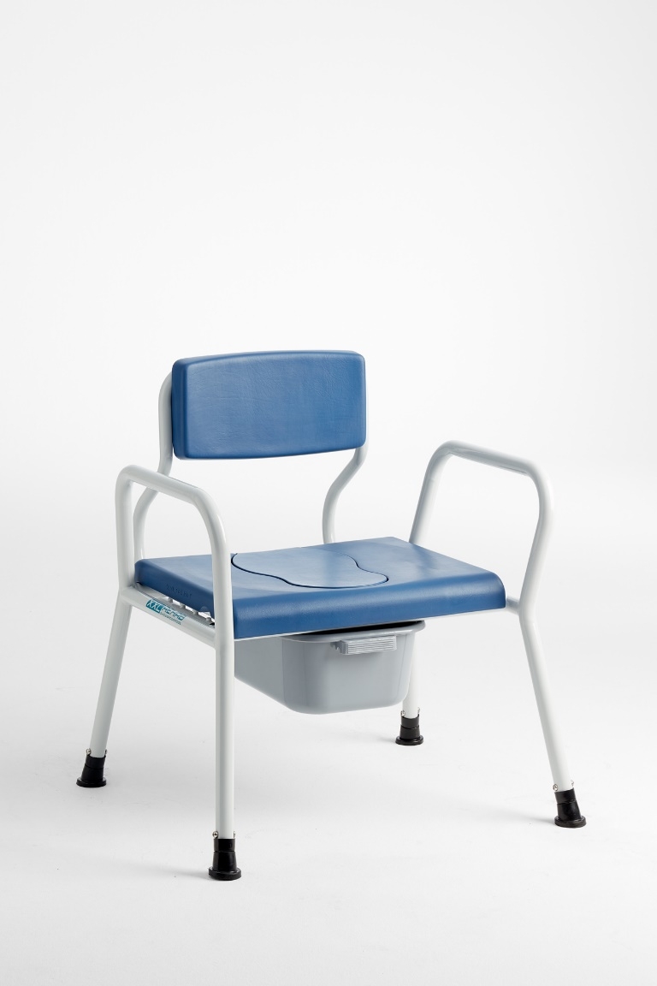





Cobi Rehab and Cobi Rehab suppliers comply with the UN conventions on child labour and forced labour as well as ILO 029, C132 and C182.

Table of content

1. Safety 3

2. Symbols 4

3. General comments 5

4. Use 5

5. Setting 5

6. Long-term storage 6

7. Cleaning and maintenance 6

8. Disposal 6

9. Warranty 7

10. Specifications 8

11. Ordering 8

|  |  |
| --- | --- |
|  | WARNING |
| Do not use the Bedside Commode Clean without thorough instructions from trained staff or from persons who have received instruction in the use of the Bedside Commode Clean. Improper operation may injure the user.  Using the Bedside Commode Clean for people weighing more than the maximum user weight of 325 kg increases the risk of damaging the Bedside Commode Clean.  Read this user manual carefully before using the Bedside Commode Clean. Pay particular attention to Safety Instructions marked .  Cobi Rehab assumes no responsibility for any damage to the product nor for personal injury caused by incorrect installation, incorrect mounting, or incorrect use of the Bedside Commode Clean.  Immediately contact Cobi Rehab if parts are damaged or missing. Never use your own spare parts.  Cobi Rehab cannot be held responsible for errors or accidents occurring after repairs are made without written permission from Cobi Rehab. | |

|  |  |
| --- | --- |
|  | SAFETY INSTRUCTIONS |
| Bedside Commode Clean may tip or break if the max. weight limit is exceeded. Maximum user weight 325 kg.  Do not use Bedside Commode Clean in pools or swimming pools.  The surface temperature can rise when Bedside Commode Clean is exposed to external heat sources e.g., sunlight.  Bedside Commode Clean may only be used on a flat, hard floor with a maximum inclination of 3 °. Larger slope increases the risk of tipping.  Bedside Commode Clean must be assembled correctly before use. See section Setting. | |

## 1. Safety

|  |  |
| --- | --- |
| The following symbols are used in this user manual  and/or on the product label. | |
|  | Caution! |
|  | Declaration of conformity, Medical Device Regulation, EU 2017/745 |
|  | Cobi Catalogue number |
|  | Serial number |
|  | Year of manufacture |
|  | Manufacturer |
|  | Medical device |
|  | Max. user weight |
|  | Consult the manual |
| CE label located at the frame.  See an example of an CE-label below. | |

## 2. Symbols

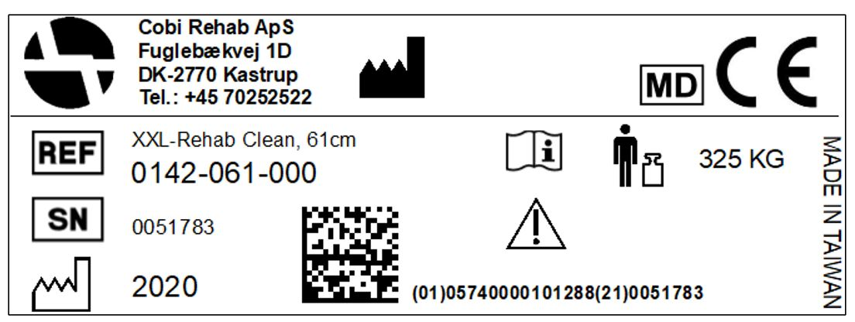

Assembly of Bedside Commode Clean

Bedside Commode Clean consists of two parts, the chair frame, and the backrest.

1. Put a washer on each bolt. Fastened the backrest to the chair frame by inserting the four bolts and washers into holes, two on each side. Tighten them well with the accompanying hexagon allen key.

Adjustment of the seat depth and backrest

1. The seat depth can be adjusted into three positions. Choose two holes (front, middle or back) on the backrest for the desired seat depth. See the instruction above.

Adjustment of the height settings of the leg

1. The height of the legs can be adjusted into six positions by loosening and tightening the four bolts already mounted on the legs. Use both hexagon allen keys when adjusting.

Tools to use

1. Two 5 mm hexagon allen keys, four hex sockets allen key bolts, four washers.

During use

The backrest can be adjusted in three different depths. Adjusting the seat depth does not affect the stability of the chair.

## 3. General comments

## 4. Use

## 5. Setting

Bedside Commode Clean is intended for users weighing up to 325 kg during lavatory use and in shower situations.

Bedside Commode Clean is used in hospitals, care centers and institutions.

Always consult a therapist before assigning Bedside Commode Clean to a user.

 Bedside Commode Clean may tip or break if the max. weight limit is exceeded.

 Bedside Commode Clean must not be used in saline environments (such as swimming pools) or in highly acidic or alkaline environments.

Contraindications

Monitor users with cognitive impairment while using the Bedside Commode Clean.

This user manual contains important information about the use of Bedside Commode Clean and the target group for Bedside Commode Clean. It also includes a wide range of specifications on the Bedside Commode Clean.

The most recent version of this user manual can be found on our website. Check if the version you are reading now is the most recent.

If you need a user manual that is written in a larger font size, the product sheet is available in PDF format at cobirehab.com, which can be scaled up to the required font size.

You can always contact Cobi Rehab at + 45 7025 2522 or [cobi@cobi.dk](mailto:cobi@cobi.dk) if you want more information about the Bedside Commode Clean.

Cobi Rehab reserves the right to change the product specifications without providing prior notice.

The UDI number of Bedside Commode Clean appears on the label, which is located on the side of the frame.

Product safety notices and product recalls can be viewed on the website.

## 6. Long-term storage

When the Bedside Commode Clean is not in use, store it in a dry place and between -10 – 40°C.

The frame, seat, and armrests of the Bedside Commode Clean must be washed with lime- and salt-neutral water using a regular cleaning agent after each use, and then wiped dry.

Environmental Restrictions

 The Bedside Commode Clean must not be used in saline environments (such as swimming pools) or in highly acidic or alkaline environments.

Disinfection

Bedside Commode Clean can be disinfected using ethanol 70-85% or a chlorine product of min. 1000 ppm and max. 10000 ppm.

 Always remember to disinfect Bedside Commode Clean when transferred to a new user. This is done to avoid cross-contamination and infections.

Local cleaning and disinfection procedures must always be followed.

Maintenance

Bolts and washers should be checked regularly and replaced if necessary.

 Failure to check bolts and washers as instructed may cause malfunction.

## 8. Disposal

Dispose of products that are no longer in use in an environmentally safe manner.

Contact your local authority or Cobi Rehab for further information on disposal.

Recycling

Contact Cobi Rehab for more information on recycling of parts of the Bedside Commode Clean.

## 7. Cleaning and maintenance

After the expected service life, it is important that an overall assessment of the product is made before continued use.

After the expected service life, Cobi Rehab cannot guarantee the suitability and safety of the product, as Cobi Rehab has no control over how the product is used and wear and tear.

The overall assessment of the product must be carried out by qualified professionals, and as a minimum, consideration must be given to how the product has been used, the condition of the product and its components.

Cobi Rehab can always make such an assessment.

### 9.2 After expiry of the expected service life

Report any unintended incident related to the use of the Bedside Commode Clean to Cobi Rehab.

### 9.1 Unintended incidents

Cobi Rehab warrants that the Bedside Commode Clean is without defects on delivery. If, against all expectations, the Bedside Commode Clean is subject to deficiencies or defects on receipt, please contact Cobi Rehab immediately.

The warranty period for the Bedside Commode Clean is one year from the date of purchase and covers manufacturing defects or defect on receipt. The invoice is your certificate of warranty.

The warranty does not apply to:

- products on which the serial number, batch number or the like have been removed or significantly damaged.

- products which have been repaired by unauthorised personnel.

The warranty does not cover:  
 - wearing parts.

The warranty does not apply when Cobi Rehab assesses that the Bedside Commode Clean has been improperly operated or used in saline, acidic, or alkaline environments.

For damage caused by improper operation, an invoice will be issued for both the service and the spare parts used.

 Lack of maintenance can damage the product, shorten the life, or affect the performance of the Bedside Commode Clean.

## 9. Warranty

|  |  |  |  |  |  |  |  |  |  |
| --- | --- | --- | --- | --- | --- | --- | --- | --- | --- |
| Maximum user weight | | | | | | | | 325 kg | |
| Seat width | | | | | | | | 610/710 mm | |
| Seat depth adjustable | | | | 400-520 mm | | | | | |
| Seat height adjustable | | | | | | | | | 440-590 mm |
| Distance between arm rests | | | | | | | | | 650/750 mm |
| Total width | | | | | | | | | 730/830 mm |
| Total height | | | | | | | | | 790-940 mm |
| Width toilet opening | | | | | Ø 240 mm, 350 mm long | | | | |
| Seat/back/arm rests | | | Polyurethane | | | | | | |
| Frame | Powder-lacquered chromium molybdenum steel/SAE41-30 | | | | | | | | |
| Weight (61 cm/71 cm) | | | 14/15 kg | | | | | | |
| ISO classification | | | | | | | 09 33 07 03 | | |
| Expected product service life | | | | | | | | | 7 years |
| Risk class | | | | | | | | | I |
| UDI-DI | | 5740000101288/5740000101295 | | | | | | | |
| Basic UDI | | | | | | 5740000100003MY | | | |
| The surface temperature can rise when the Bedside Commode Clean is exposed to external heat sources e.g., sunlight. | | | | | | | | | |

## 10. Specifications

## 11. Ordering

|  |  |
| --- | --- |
| Model | Item number |
| Bariatric Bedside Commode Clean, 61 cm | 0142-061-000 |
| Bariatric Bedside Commode Clean, 71 cm | 0142-071-000 |
| Seat for Bedside Commode Clean, 61 cm | 0150-999-022 |
| Seat for Bedside Commode Clean, 71 cm | 0150-999-023 |
| Bedpan with cover | 0140-999-001 |
| Ferrules, rubber, 1 piece | 0140-999-112 |





MANUFACTURER

Cobi Rehab  
Fuglebækvej 1D  
DK-2770 Kastrup  
Denmark  
+45 7025 2522

[cobirehab.com](https://www.cobirehab.com/en/)