Actuators  
Rise N Tilt is equipped with four actuators, located under the seat. The four actuators ensure that Rise N Tilt can lift and tilt.

Do not remove the battery from the control box until five seconds after the last actuator has stopped. In this case, Rise N Tilt must be calibrated to function again. **See Troubleshooting**.

If two or more actuators run uneven, the control box shuts down. In this case, Rise N Tilt must be calibrated. **See Troubleshooting.**

Troubleshooting  
In the event of operational problems, it is important to check that all connections are correctly in both the control box, remote control and between the battery and the control box.

If the actuators are out of function, Rise N Tilt must be starting point calibrated.

Starting Point Calibration  
A starting point calibration is done by pressing the two lower buttons on the remote control until Rise N Tilt has been lowered to the "bottom position".

The calibration is now complete, and the actuators can run again.

Charging error  
In the event of a problem in the charger function, the yellow LED on the battery flashes.

1. Unplug the cord.

2. Wait two minutes, then re-insert the cord.

If all LEDs flash, it is due to operating problems in the control box. It requires a starting point calibration of Rise N Tilt. **See troubleshooting.**

Please contact your dealer in case of operational problems.

Quick guide updated June 2024.

Rise N Tilt Shower Commode

Charging and operation

quick guide

|  |  |
| --- | --- |
| Status | Battery |
| Fully charged | >85% |
| Medium charged | 85 – 40% |
| Almost empty | 40 – 20% |

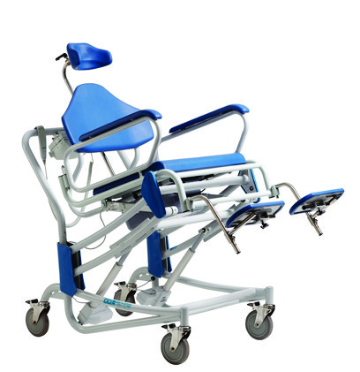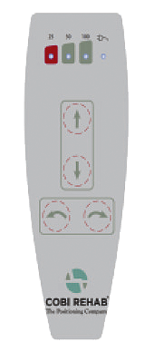

Preparation

Charge the battery before using Rise N Tilt. The battery is in the control box, which is mounted on the handle.

A complete charge takes up to 10 hours.

When the control box with battery is connected to power a light is visible in the yellow diode on the battery. When the battery is fully charged, the yellow LED light is no longer visible

After charging, all three LEDs on the remote-control light up at the same time. Charge the battery every day after use.

Low battery

With 25% of the battery left, Rise N Tilt can only go down. This ensures the user can always be taken down.

Hard load on battery  
Hard load on the battery

(Many times, up and down one after the other) leads to the battery becoming too hot and that the safety thermostat in the battery is activated.

This means the control box is shut down and that the battery must cool down for at least half an hour before it can be used again. Allow at least one minute before another battery is inserted into the controller.

Always have an extra charged battery available.

 Rise N Tilt Shower Commode must not be used in salty environments (swimming pools or public baths) or in highly acidic or alkaline environments.

Starting Point Calibration

Press the two lower buttons until Rise N Tilt has been lowered.

Fully charged battery with three lit diodes.

Fjernbetjening   
For kalibrering/  
reset af stolens bevægelser: Hold de to nederste knapper nede, indtil stolens position er i bund.