User manual

Rise N Tilt Shower Commode

The world’s first shower commode that lifts and tilts the bariatric user to a 30° angle. A carefully considered and safe combination chair that takes both the user and the caregiver into consideration in any bathing situation.

Rise N Tilt Shower Commode is used in care homes, institutions, and hospitals.   
User weight up to 325 kg.

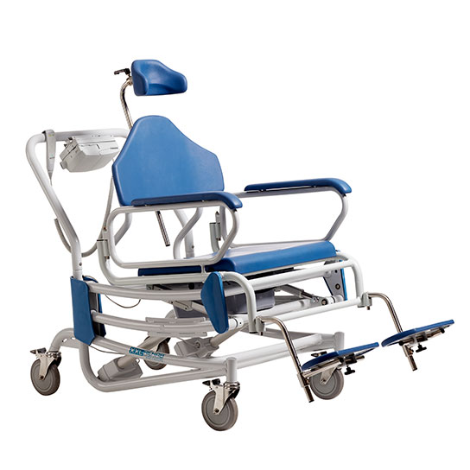

UP TO 325 KG

* Brakes on all four wheels.
* Optional extra-wide butterfly arm rests.
* Remote control provides the carer with easy access to the electrical functions.
* Ensures a better working environment for the carer and a comfortable and safe bathing experience for the user.
* Adjustable seat height and seat depth.
* Several types of leg rests.

Scan or click on the code and find the product at the Danish AssistData.





Cobi Rehab and Cobi Rehab suppliers comply with the UN conventions on child labour and forced labour as well as ILO 029, C132 and C182.

Table of content

1. Safety 3

2. Explanation of symbols 4

3. General comments 5

4. Application 5

5. Use 6

6. Charging and operation 7

7. Actuators 8

8. Maintenance and cleaning 9

9. Transport and storage 9

10. Recycling and disposal 10

11. Warranty 10

12. Specifications 11

13. Accessories and spare parts 12

|  |  |
| --- | --- |
|  | WARNING |
| Do not use the Rise N Tilt Shower Commode without thorough instruction from trained staff or from persons who have received instruction in the use of the shower commode. Improper operation may injure the user.  Using the Rise N Tilt Shower Commode for people weighing more than the maximum user weight of 325 kg increases the risk of damaging the commode.  Read this user manual carefully before using the Rise N Tilt Shower Commode. Pay particular attention to Safety Instructions marked .  Cobi Rehab assumes no responsibility for any damage to the product nor for personal injury caused by incorrect installation, incorrect mounting, or incorrect use of the Rise N Tilt Shower Commode.  Immediately contact Cobi Rehab if parts are damaged or missing. Never use your own spare parts.  Cobi Rehab cannot be held responsible for errors or accidents occurring after repairs are made without written permission from Cobi Rehab. | |

## 1. Safety

|  |  |
| --- | --- |
|  | SAFETY INSTRUCTIONS |
| In this user manual, the symbol  indicates a safety instruction. Follow safety instructions carefully.   * The caregiver staff assesses whether the user should be restrained in the Rise N Tilt during use for safety reasons.   Always lift users not able to stand and walk in and out of the Rise N Tilt.  Always take care when using the tilt-in-space and recline function to avoid jerky movements.  The maximum user weight of the Rise N Tilt is 325 kg.  The surface temperature can rise when the shower commode is exposed to external heat sources e.g., sunlight.  Due to its large width, the Rise N Tilt Shower Commode may have difficulty passing through ordinary doorways and emergency exits.  Always use helper control for users with impaired cognitive function.  Always ensure that the wheelchair is charged.  The charging cable must always be disconnected from the control box in bathing situations.  Rise N Tilt Shower Commode may only be used on a flat, hard floor with a maximum inclination of 3°. Larger slope increases the risk of tipping. | |

|  |  |
| --- | --- |
|  | Caution! |
|  | Double insulated (class II) |
|  | Declaration of conformity, Medical Device Regulation, EU 2017/745 |
| IPX6 | IP-classification |
|  | Dispose of through correct waste management |
|  | Cobi Catalogue number |
|  | Serial number |
|  | Year of manufacture |
|  | Manufacturer |
|  | Medical device |
|  | Max. user weight |
|  | Consult the manual |
| CE label located at the frame.  See an example of an CE-label below. | |

## 2. Explanation of symbols

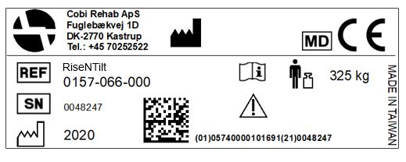

This user guide contains important information about the use of the Rise N Tilt Shower Commode and the target group for the shower commode. It also includes a wide range of specifications on the Rise N Tilt Shower Commode.

The most recent version of this user guide can be found on our website. Check if the version you are reading now is the most recent.

If you need a user guide that is written in a larger font size, the product sheet is available in PDF format at cobirehab.com, which can be scaled up to the required font size.

You can always contact Cobi Rehab on telephone + 45 7025 2522 or [cobi@cobi.dk](mailto:cobi@cobi.dk) if you want more information about the Rise N Tilt Shower Commode.

Cobi Rehab reserves the right to change the product specifications without providing prior notice.

The UDI number of the shower commode appears on the label, which is located on the side of the frame.

Product safety notices and product recalls can be viewed on the website.

## 3. General comments

Rise N Tilt Shower Commode is designed for indoor use in e.g., hospitals, care centres and institutions.

The Shower Commode is intended for bariatric users of up to 325 kg with reduced physical functional capacity.

 Rise N Tilt Shower Commode is not intended for traversing obstacles such as doorsteps, etc. The shower commode should only be used on a firm surface to avoid the risk of tipping.

The intended operator of the Rise N Tilt Shower Commode is a health professional, such as a therapist, nurse, or social and healthcare worker.

Rise N Tilt Shower Commode can be used in environments with a temperature range of 0-40°C and a humidity interval of 20-80%.

 Rise N Tilt Shower Commode must not be used in salty environments (swimming pools or public baths) or in highly acidic or alkaline environments.

Contraindications

Monitor users with cognitive impairment while using the Rise N Tilt Shower Commode.

## 4. Application

### While in use

 The user must not use the footrests to stand on or as a step during transfer as this may lead to a risk of tipping.

Risk of trapping 

- Mounting the arm rests while the user occupies the shower commode, may cause trapping between the arm rest and the side of the chair.

- A foot may be trapped between the footrests if the lock bolts are not correctly mounted in the footrests.

- Fingers and other body parts may be trapped between the seat frame of the shower commode and a toilet bowl or the bedpan. Therefore, always exercise great care when moving the shower commode above a toilet, or when the bedpan is inserted underneath the seat.

- A caregiver’s hand may be trapped between the handlebar and the seat frame when the seat is in the top-most position.

 Always make sure to brake at least two wheels when transferring the user to and from Rise N Tilt Shower commode and when the user occupies the shower commode.

When transporting the user, the seat must be lowered as far down as possible, as it may otherwise tip.

 The charging cable must always be disconnected from the control box in bathing situations.

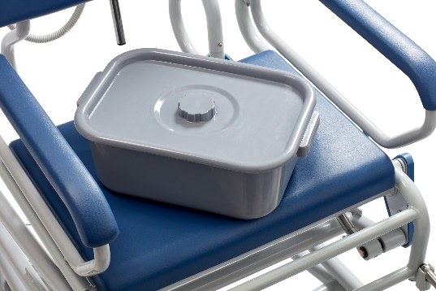

Bedpan with cover.   
Easy to insert and empty.

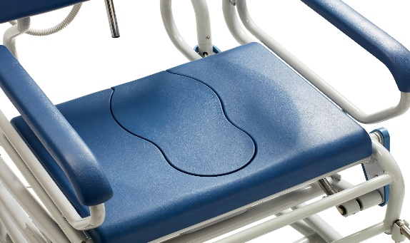

Rise N Tilt is a unique combination of a commode chair and a shower chair.

### Before use

The arm rests must be correctly mounted in the holes on the side of the shower commode.

The width of the footrests may be gradually adjusted. Always mount the lock bolts under the footrests correctly in the footrest holes.

The lock bolts must not be tightened against the footrest outside the holes.

Ensure that the seat is correctly mounted on the seat frame of the shower commode.

Do not use the shower commode until both arm rests have been mounted. Without arm rests, the user may fall sideways.

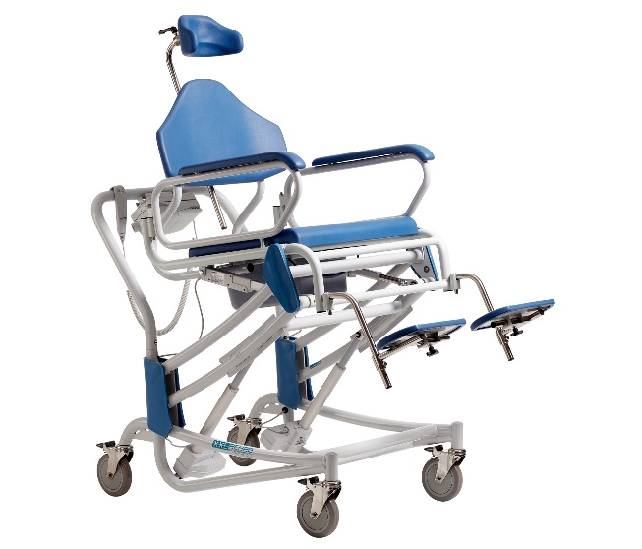

Rise N Tilt makes it easier for care staff to perform daily hygiene and care for skin and tissue.

## 5. Use

Before using the shower commode, the battery must be charged. The battery is located inside the control box which is mounted on the handlebar. Charging the battery takes up to 10 hours.

When connecting the control box with the battery to the power supply, the yellow LED on the battery lights up. Once the battery has been charged, the yellow LED switches off.

Once the charge is complete, all three LEDs on the remote-control light up at the same time.

Charging the shower commode every day after use is recommended.

Low battery level

With a 25% charge, the shower commode can only move downwards. This ensures that the user can always be lifted down.

Hard strain on battery

If the battery is heavily strained with many successive up-and-down movements, the battery may become too hot, thus activating the safety thermostat inside the battery.

This means that the control box will stop working. The battery must be allowed to cool down for at least 30 minutes before being used again. At least one minute must be allowed to pass before another battery is installed in the control.

Always having a charged battery to hand is recommended.

### 6.1 Preparation

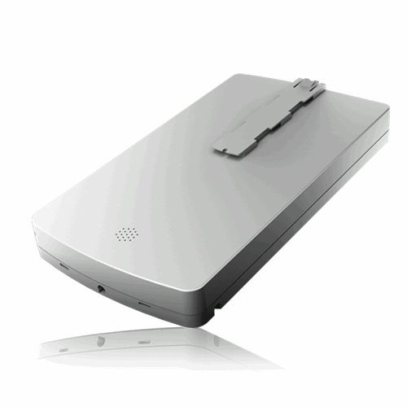

Accompanying battery for charging. Located in the control box and charged directly from there.

## 6. Charging and operation

The Rise N Tilt Shower commode is equipped with four actuators located under the seat. These four actuators provide the lifting and tilting function of the shower commode.

Please note that the battery must not be removed from the control box until five seconds after the last actuator has stopped. Should this occur, the bath-and commode chair must be calibrated.

**See section 7.1.**

If e.g., the two actuators that control the tilt have been lowered, the control box will shut these down. This also applies if the two actuators that control lifting run skewed, or if all four actuators run skewed at the same time.

Should this occur, the shower commode must be calibrated.   
**See section 7.1.**

## 7. Actuators

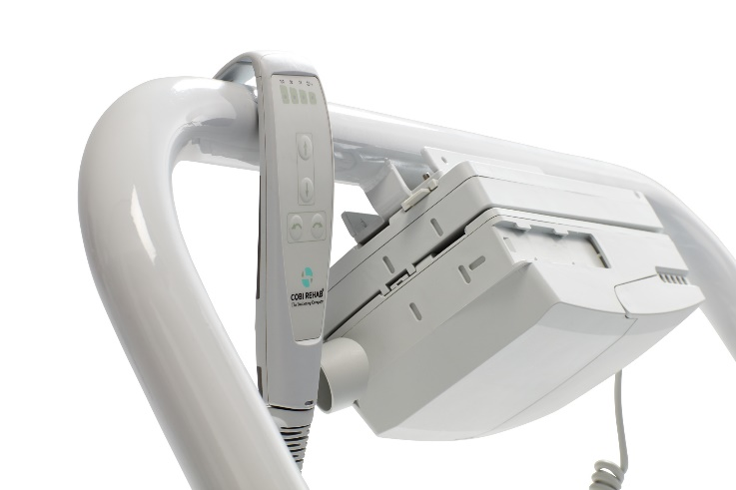

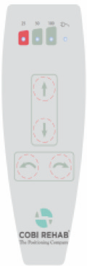

If issues with operation arise, it is important to check that all plugs are correctly connected to the control box and the remote control as well as between the battery and the control box.

If the actuators do not work, the shower commode must be 0-point calibrated.

A 0-point calibration is performed by pressing the two bottom buttons of the remote control until the shower commode has reached the ”bottom position”. The calibration has not been completed and the actuators are able to move again.

Charging error

In case of charging errors, the yellow battery LED will blink.

1. Remove the lead from the power supply.  
2. Wait to minutes and reconnect the lead.

If all LEDs blink, this is a signal of irregularities in the electrical functions of the shower commode. This requires a 0-point calibration:

Press the two bottom buttons of the remote control until the shower commode has reached the ”bottom position”.

In case of other irregularities, please contact Cobi Rehab at +45 7025 2522 or at cobi@cobi.dk.

### 7.1 Calibrating the actuators using the remote control

The frame, seat, and armrests of the Rise N Tilt Shower Commode must be washed with lime- and salt-neutral water using a regular cleaning agent after use and then dried.

 The Rise N Tilt Shower Commode must not be used in salty environments (swimming pools or public baths) or in highly acidic or alkaline environments.

Disinfection

The seat can be removed and disinfected with ethanol 70-85% or a chlorine product with a minimum concentration of 1000 ppm and a maximum of 10000 ppm.

 Always disinfect the Rise N Tilt Shower Commode before transferring it to a new user to avoid cross-contamination.

Any local procedures regarding cleaning and maintenance must always be followed.

 Failure to inspect bolts may result in malfunction.

Battery handling

Always use batteries that are in good condition and fully charged when installed in the control box.

Battery life can be extended by recharging it albeit if it is not entirely flat.

If the control box is not to be used for a considerable period (days and weeks), the battery should be removed from the control box to prevent it from being completely discharged which could cause permanent damage to the battery.

## 8. Maintenance and cleaning

## 9. Transport and storage

When the shower commode is not in use, store it in a dry place and between -10 – 40°C.

The Rise N Tilt Shower Commode is suitable for land and/or air transport (without the user). The Rise N Tilt Shower Commode cannot be folded as the frame is fixed.

To avoid injuries to e.g., the back, care staff should refrain from carrying the 46 kg shower commode. If it is to be transported, the Rise N Tilt Shower Commode can be lifted by the frame, without the user being seated in it, into a motor vehicle.

When storing the Rise N Tilt Shower Commode for a longer period (more than three months), store it in 0-40°C and a humidity not exceeding 80 %.

It is recommended that the battery is charged to 60 % prior to storage.

When putting the Rise N Tilt Shower Commode into use again after long-term storage, it must be connected to the power supply and charged for at least ten hours.

Keep an eye on the battery capacity as the Rise N Tilt Shower Commode will discharge over time.

### 9.1 Long-term storage

Cobi Rehab warrants that the Rise N Tilt Shower Commode is without defects on delivery. If, against all expectations, the Rise N Tilt Shower Commode is subject to deficiencies or defects on receipt, please contact Cobi Rehab immediately.

The warranty period for the Rise N Tilt Shower Commode is one year from the date of purchase and covers manufacturing defects or defect on receipt. The invoice is your certificate of warranty.

The warranty does not apply to:

- products on which the serial number, batch number or the like have been removed or significantly damaged.

- products which have been repaired by unauthorised personnel.

The warranty does not cover:  
 - wearing parts.

This warranty does not apply when Cobi Rehab assesses that the Rise N Tilt Shower Commode has been improperly operated or used in salty environments (swimming pools or public baths) or in highly acidic or alkaline environments.

For damage caused by improper operation, an invoice will be issued for both the service and the spare parts used.

 Lack of maintenance can damage the product, shorten the life, or affect the performance of the Rise N Tilt Shower Commode.

Dispose of products that are no longer in use in an environmentally safe manner.

Contact your local authority or Cobi Rehab for further information on disposal.

Contact Cobi Rehab for more information on the recycling of Lithium batteries and parts of the Rise N Tilt Shower Commode.

After the expected service life, it is important that an overall assessment of the product is made before continued use.

After the expected service life, Cobi Rehab cannot guarantee the suitability and safety of the product, as Cobi Rehab has no control over how the product is used and wear and tear.

The overall assessment of the product must be carried out by qualified professionals, and as a minimum, consideration must be given to how the product has been used, the condition of the product and its components.

Cobi Rehab can always make such an assessment.

### 11.2 After expiry of the expected service life

Report any unintended incidents related to the use of the Rise N Tilt Shower Commode to Cobi Rehab.

### 11.1 Unintended event

## 10. Recycling and disposal

## 11. Warranty

|  |  |  |  |  |  |  |  |
| --- | --- | --- | --- | --- | --- | --- | --- |
| Max. user weight 12. Specifications | | | 325 kg | | | | |
| Risk class | | | I | | | | |
| Basic UDI DI | | | 5740000100005N4 | | | | |
| Expected product service life | | | 7 years | | | | |
| Expected battery service life | | | 2-3 years | | | | |
| Total length in low position | | | 1400 mm | | | | |
| Total width standard arm rests/butterfly arm rests | | | | | 740/850 mm | | |
| Seat width | | | 610 mm | | | | |
| Seat depth adjustable | | | | | | | 420/480/540 mm |
| Seat angle electric backwards | | | 0-30° | | | | |
| Seat angle independent of height adjustment | | | | Yes | | | |
| Width between standard arm rest/butterfly arm rest | | | | | | 610 mm/750 mm | |
| Width toilet opening | | | Ø 240 mm, 350 mm long | | | | |
| Seat height electric adjustable | | | 550-1110 mm | | | | |
| Distance from ground to seat underside | | | 445 mm | | | | |
| Distance from ground to push bar | | | 1000 mm | | | | |
| Distance from seat to footrests | | | 390/420/450/480 mm | | | | |
| Distance from seat to arm rests | | | 220 mm | | | | |
| Total weight of Rise N Tilt Shower Commode | | | 46 kg | | | | |
| Swing away arm rests | | | Yes | | | | |
| Footrests and folding | | Yes | | | | | |
| Footrests swing away, hight adjustable | | | Yes | | | | |
| Neck support | Yes | | | | | | |
| Lockable wheels | Yes, 4 | | | | | | |
| Up/down capacity with fully charged battery | | | Approx. 15 times | | | | |
| Turning radius | | | 1560 mm | | | | |
| Frame | | | Powder-coated chrome molybdenum steel | | | | |
| Wheels | | | Ø150 mm with brake | | | | |
| Seat/back/arm rests | | | Polyurethane | | | | |
| IP-classification | | | IPX6 | | | | |
| ISO-classification | | | 09 12 03 - 23 | | | | |
| Four actuators | | | LINAK A20/A40 | | | | |
| Control box | | | LINAK | | | | |
| Remote control | | | LINAK | | | | |
| Risk assessment | | | EN/ISO 14971: 2012 | | | | |
| General requirements and test methods | | | EN 12182:2012 | | | | |

|  |  |
| --- | --- |
| Accessory | Part number |
| Butterfly arm rest right (adds 7 cm width between the arm rest) | 0150-999-012R |
| Butterfly arm rest left (adds 7 cm width between the arm rest) | 0150-999-012L |
| Neck support adjustable | 0156-999-020 |
| Seat entirely with cover for shower commode | 0150-999-023 |
| Bedpan with cover plastic | 0140-999-001 |
| Foot rest standard shower commode right | 0156-999-090H |
| Foot rest standard shower commode left | 0156-999-090V |
| Lateral leg rest for shower commode right | 0156-999-030 |
| Lateral leg rest for shower commode left | 0156-999-031 |
| Battery for Rise N Tilt Shower Commode | 0157-999-050 |

## 13. Accessories and spare parts





MANUFACTURER

Cobi Rehab  
Fuglebækvej 1D  
DK-2770 Kastrup  
Denmark  
+45 7025 2522

cobirehab.com

DesinfektionBrug en 75-80° spritopløsning til desinfektion af puderamme, andre metaldele og indsatspuden.

SmøringDet er ikke nødvendigt at smøre Reden.

ReparationVed reparation af Reden gælder de generelle sikkerhedsforskrifter og følgende:

-Ved udskiftning af sliddele og/eller ved behov for andre reservedele kontakt Cobi Rehab.

-Brug aldrig uoriginale reservedele eller tilbehør (undtaget puder), da dette kan påvirke produktets godkendelse, levetid, sikkerhed og EMC.

-Reservedelene bestilles ud fra Cobi Rehab reservedelsliste (se side 16).

Kontakt Cobi Rehab ved større reparationsarbejde.

**Årligt eftersyn**

Få foretaget et årligt eftersyn af Reden af Cobi Rehab. Her kontrolleres Redens funktioner, elektronik og motorer, ligesom der udføres mindre vedligeholdelser som fx efterspænding og justering af bremser.

### 9.3 Øvrige